Developing Multiplication Automaticity to Increase Access to the
Sixth Grade Mathematics Curriculum and Instruction
Lindsay N. Boylan
A Capstone Presented to the Teachers College Faculty
of Western Governors University
in Partial Fulfillment of the Requirements for the Degree
Master of Arts in Elementary Mathematics Education
April 10, 2014
Student Mentor: Casilyn Lewis
Capstone Facilitator: Dr. Robert Murray

Abstract
Many students struggle with automatic recall of the basic multiplication facts, even after learning how to multiply in the early grades. Educators must find ways to remediate instruction to meet the needs of these students while concurrently teaching the required course curriculum. Using a mixed methods action research paradigm, a modified Detect, Practice, and Repair (DPR) procedure was used to determine if it is an effective and efficient method to increase sixth grade students’ automatic recall of basic multiplication facts. The quantitative and qualitative data, when triangulated, suggest that a modified DPR procedure can be effective in increasing basic multiplication fact fluency and automaticity. However, continual refinement of the process would be needed to maximize its potential as an effective remedial strategy.

Table of Contents

Chapter 1: Topic and Problem.........................................................................................................6

Multiplication Fact Fluency…….....................................................................................................6

Possible ramifications from lack of fluency.......................................................................8

Importance of fluency..........................................................................................................9

Problem Statement.........................................................................................................................10

Problem background..........................................................................................................10

Significance of the problem...............................................................................................11

Possible causes………………………………………………….......................................11

Research Questions........................................................................................................................12

Conclusions and Future Study…..................................................................................................12

Chapter 2: Review of the Literature..............................................................................................13

Overview of the Literature.............................................................................................................13

Theories on Fluency……...............................................................................................................13

Prior Research................................................................................................................................14

Best Practices Research.................................................................................................................16

Lack of Fluency………………………………………………………………………………….18

Summary........................................................................................................................................19

Chapter 3: Research Methodology……………………………………………………………….20
Overview of the Research Methodology………………………………………………………...20
Research Questions………………………………………………………………………………20
Hypothesis…..................................................................................................................................21
Research Design…………….……………………………………………………………………21
Participants……………………………………………………………………………………….21
Permissions………………………………………………………………………………22
Evaluation Methods and Tools…………………………………………………………………..22
Validity and reliability…………………………………………………………………...24
Data integrity…………………………………………………………………………….24
Method Adoption………………………………………………………………………………...25
Differences……………………………………………………………………………………….27
Summary ..……………………………………………………………………………………….27
Chapter 4: Findings………………………………………………………………………………29
Results Overview….......................................................................................................................29
Data Driven Findings Summary…………………………………………………………………29
Data Analysis…………………………………………………………………………………….30
Quantitative data…………………………………………………………………………30
Qualitative data…………………………………………………………………………..33
Answers to the Research Questions……………………………………………………………...36
Findings Summary……………………………………………………………………………….38
Chapter 5: Discussion and Conclusion…………………………………………………………..39
Overview…………………………………………………………………………………………39
Problem Solutions…......................................................................................................................39
Strengths………………………………………………………………………….…………..….39
Weaknesses…...………………………………………………………………………………….40
Problems Encountered…………………………………………………………………………...40
Influential Factors…......................................................................................................................40
Implications………………………………………………………………………………………40
Limitations….................................................................................................................................41
Recommendations……..…………………………………………………………………………41
Improvement……………………………………………………………………………..41
Further investigation……………………………………………………………………..42
Master’s Degree Experience……………………………………………………………………..42
Implementation…………………………………………………………………………………..43
Project Summary and Conclusion…..............................................................................................43
References………………………………………………………………………………………..45
Appendix A………………………………………………………………………………………49
Appendix B………………………………………………………………………………………53
Appendix C…................................................................................................................................57
Appendix D………………………………………………………………………………………59
Chapter 1
Topic and Problem
Multiplication Fact Fluency
North Carolina public school teachers must choose and implement effective instructional techniques to help students memorize the multiplication facts. Beginning with the 2013-2014 school year, students enrolled in North Carolina public schools will be required to, “memorize multiplication tables to demonstrate competency in efficiently multiplying numbers” (S.L. 2013 -71, p. 1). This requirement, in addition to the Common Core State Standards and other additions to the standard course of study, obliges public school teachers to find time and resources to ensure public school students memorize the basic multiplication facts. Thus, one of the problems public school teachers now face is determining when and how to accomplish this task.
At this time, the legislation is not specific in regards to the scope of multiplication facts to be memorized or what in grade levels to accomplish this. However, based on the newly implemented Common Core Standards, third grade students begin working with multiplication and division of whole numbers. This skill set is expanded upon in fourth grade and is essential to students’ continued learning and mastery of advanced mathematical concepts and procedures. As students are promoted through upper elementary, middle, and high school, the ability to quickly recall basic multiplication facts becomes a near necessity. More complex mathematical concepts and procedures frequently incorporate multiplication into their processes. Students that are still struggling with basic multiplication can become overwhelmed with the demands of the task.
In a study of K- 8 mathematics curriculum pressure points, “a topic, skill, or concept that is crucial to future mathematics learning but which many or most students do not master to the extent expected at a given grade level” (Rheinlander et al., 2008, abstract), the number of pressure points in a grade level is extensive;

The list of items to be covered in the fifth grade curriculum was truly huge:
addition, subtraction, multiplication, and division especially when fractions,
decimals and more than one-digit numbers are involved; problem solving and
strategies for multi-step processes: order of operations, organization, identifying
estimation and rounding numbers; fractions: factors, proportionality, ratio,
decimals, percentages, discounts, tax, least common denominator, equivalents;
place value of decimals to the billions; measurements: types of triangles and
angles, use of protractors and compasses, measuring 1/8 and 1/16 of an inch;
conversion to the metric system; elapsed time; algebra: solving for the unknown
variable; negative numbers; geometry: area, perimeter, volume of polygons and
circles, classifying shapes, two and three dimensions, congruence, coordinates,
graphing, angles, plotting points given with their coordinates, coordinate plane;
number line; slope; negative numbers; patterns and rules; number series;
probability; number sense; judging the reasonableness of problem-solving
methods and solutions; language (articulation, internalization, retention); problem
solving and ability to express solution strategies verbally in written sentences;
algorithms; equations; concrete and abstract thinking; conceptual understanding
of operations; and freedom and ease of playing with mathematical concepts.
Understandably, when asked to identify items presenting particular
difficulties for students, the list for fifth grade was correspondingly longer:
developing a number sense; reasonableness of the answers; fluency and ease with
numbers; “numeracy;” the number line concept; having a solid ability to compute;
conceptual understanding of operations; language issues; articulation,
internalization, retention of math terms; basic problem solving strategies,
especially with multi-step processes; understanding that there are different ways
to find a solution; place value, addition, subtraction skills; mastery of math facts
for addition, subtraction, multiplication; accuracy and speed in problem solving;
generalizing a problem or a technique to a new situation; rounding and estimating;
understanding decimals as well as division with a decimal or fraction and
explaining the process with words; and multiplying fractions: what does 1/4 of 1/2
mean? The teachers also expressed frustration that the mathematics curriculum
was too broad and the expectations for the pace of learning too fast in fifth grade,
resulting in students who lack depth of knowledge and/or have not mastered
essential fundamentals (p. 6-7).
Coupled with the rigor of the current mathematics curriculum, teachers and students are pushed to learn more content with less time and, too often, without acquiring fluency in basic facts.
Possible ramifications from lack of fluency. Data from the 2013 National Assessment of Educational Progress (NAEP) indicates a large decline in mathematical proficiency between fourth and eighth grade. Eighteen percent of fourth grade males and 17 percent of fourth grade females scored below basic and additional 30 percent of males and 35 percent of females in fourth grade scored below proficient on the 2013 NAEP in mathematics. The number of students below proficiency in eighth grade increases to 54 percent for males and 57 percent for females. Both genders had 26 percent of eighth grade students scoring below basic (National Center for Education Statistics, 2013). It is possible that a lack of fluency with basic numeracy, including basic multiplication facts, is responsible for the increase in the number of students that are not proficient by eighth grade. Observations reported by several middle school math teachers (personal communications, Nov. 2013, Dec. 2013) reveal that many sixth and seventh grade students that have been taught multiplication concepts and procedures still lack the ability to directly recall the basic multiplication facts. This deficiency hinders these students’ abilities to solve more complex mathematical problems that are integrated into the sixth grade curriculum. “… how well students master foundational skills impacts the acquisition of subsequent skills” (Lin and Kubina, 2005, p. 74). By increasing basic multiplication fluency, students may be able to more fully comprehend and utilize the middle school mathematics curriculum. Application research suggests that there is a relationship between fluency in basic skills and subsequent acquisition of more complex skills (Lin and Kubina, 2005).
Importance of fluency. According to Kubina and Morrison (2000), “fluency describes proficient, masterful, expert, and automatic performances” (p. 89). Students’ performance in mathematics is dependent on numerous factors. As students progress through the typical public school mathematics curriculum, it is imperative that they have a solid foundation in basic numeracy, basic mathematical concepts, and basic mathematical procedures. In 2008, the National Mathematics Advisory Panel (NMAP) suggested that “the recognition of the mutually reinforcing benefits of conceptual understanding, procedural fluency, and automatic (i.e., quick and effortless) recall of facts” (p. xiv) is one of the most important characteristics of effective mathematics instruction. Studies indicate the many U.S. students do not reach the point of fast and efficient solving of single-digit multiplication and are much less fluent in the execution of more complex algorithms when compared to students in other countries (NMAP, 2008). Research in applications emphasizes the relationship between obtaining fluency with component skills and the subsequent attainment of related composite skills, or, that mastery of foundational skills impacts the acquisition of subsequent skills (Lin and Kubina, 2005). Without fluency in the foundations of mathematics, it is difficult to comprehend and work with more complex mathematical situations. In fact, in a study of 155 fifth-grade students (Lin and Kubina, 2005), component fluency was the most powerful indicator for composite fluency. Development of fluency means that more cognitive capacity is available for problem solving (Caron, 2007) and less declarative and procedural errors will occur (Woodward, 2006).
Problem Statement
Many sixth grade students that have been taught multiplication concepts and procedures still lack the ability to directly recall the basic multiplication facts. This deficiency hinders students’ abilities to solve more complex mathematical problems that are integrated into the sixth grade curriculum. By increasing multiplication fluency students may be able to more fully comprehend and utilize the sixth grade mathematics curriculum.
Problem background. Through informal discussions with mathematics teachers in one middle school, it appears that too many students are still struggling with multiplication that is embedded within a more complex problem. Multiple discussions with one sixth grade mathematics instructor revealed that the majority of students in one particular section of sixth grade mathematics are currently demonstrating a lack of automaticity with basic multiplication (facts with factors between zero and ten, i.e., 5 x 8 = 40, 7 x6 = 42, etc.). According to the mathematics teacher for the course, this lack of fluency is hindering their ability to, specifically, multiply multi-digit decimals and divide fractions by fractions. The teacher reports that at least two-thirds of the target students consistently ask for the products to basic multiplication facts while attempting to complete multi-step problems involving multiplication. Overall, this lack of fluency is detrimental to the expectation that these students meet the requirements for mastery of the required curriculum (K. Delaney, personal communication, October 11, 2013).
Significance of the problem. When students have not memorized the basic multiplication facts, it is more difficult for them to complete more complex mathematical problems such as long division and, later, algebra. While students may have developed strategies for computing the needed multiplication facts, these strategies become inefficient and divert students’ attention from the more complex skill(s) needed to solve the given problem. If this research supports the use of varied daily reviews to increase students’ mathematical performance, then teachers can use this strategy to help students that did not memorize the basic facts in third grade. By improving fact fluency and recall, students will be able to put more cognitive energy into solving more complex mathematical problems.
Possible causes. One likely cause of the difficulty these students are experiencing is the breadth of the current curriculum for mathematics. The Teachers Talk discussions focusing on pressure points in the kindergarten through eighth grade mathematics curriculum reiterate the claim that the current curriculum is too broad to expect students to fully master foundational skills such as multiplication. Another possible cause is the level of motivation students have to memorize the basic facts (Lin & Kubina, 2005). Students that hold the belief that they can “always use a calculator” find no reason to spend time memorizing the basic multiplication facts. Other students may believe that it is easier to calculate the solutions to multiplication problems as needed. Indeed, there are students with mathematical learning disabilities, or even generalized learning disabilities, which hinder their ability to memorize this information. A third possible cause for a widespread lack of fluency is that students have not had sufficient amounts of practice to help them commit the basic multiplication facts to memory (Codding, Archer, & Connell, 2010; Lin & Kubina, 2005).

Research Questions
Does a brief daily review of multiplication facts increase students’ automaticity as measured by a fact fluency pretest and posttest?
How do students feel about reviewing multiplication facts to increase their automaticity as measured by a 4-point Likert scale?
How do teachers feel about using brief daily reviews to increase student automaticity as measured by interview protocols?
Conclusion and Future Study
While some students are clearly behind in mathematical proficiency, what can teachers do to remediate deficiencies while still teaching the required grade level curricula? Incorporating daily review drills for basic facts is one strategy that may be effective. This proposed action research seeks to determine if a brief daily review of basic multiplication facts will increase fact fluency and if students and teachers find it to be a useful strategy for increasing mathematical skills.

Chapter 2
Review of the Literature
Overview of the Literature
A review of the literature finds numerous ways researchers have attempted to find effective methods for increasing students’ fluency and automatic recall of the basic multiplication facts. Several studies looked at various drill methods while others focused on a combination of drill and other types of instruction or novel approaches to the problem of non-fluent students.
Theories on Fluency
“Fluency describes proficient, masterful, expert, and automatic performances” (Kubina and Morrison, 2000, p.89). Students’ performance in mathematics is dependent on numerous factors. As students progress through the typical public school mathematics curriculum, it is imperative that they have a solid foundation in basic numeracy, basic mathematical concepts, and basic mathematical procedures. The National Mathematics Advisory Panel (NMAP) (2008) suggests that “the recognition of the mutually reinforcing benefits of conceptual understanding, procedural fluency, and automatic (i.e., quick and effortless) recall of facts” (p. xiv) is one of the most important characteristics of effective mathematics instruction. The panel recommends that by the end of grade five or six students have a “robust sense of numeracy” including computational facility, which requires the automatic recall of multiplication facts. Fluency with the standard algorithms for multiplication is dependent on the automaticity of fact recall (p. 17).
Studies indicate the many U.S. students do not reach the point of fast and efficient solving of single-digit multiplication and are much less fluent in the execution of more complex algorithms when compared to students in other countries (NMAP, 2008). Unfortunately, many students with fact fluency deficits in elementary school fail to catch up to their peers without specific interventions. Deficits in computational fluency compound difficulties for students as the math curriculum becomes more complex (Geary, 2004). Research in applications emphasizes the relationship between obtaining fluency with component skills and the subsequent attainment of related composite skills, or, that mastery of foundational skills impacts the acquisition of subsequent skills (Lin and Kubina, 2005). “For all content areas, practice allows students to achieve automaticity of basic skills which frees up working memory for more complex aspects of problem solving” (NMAP, 2008, p.30). Without fluency in the foundations of mathematics, it is difficult to comprehend and work with more complex mathematical situations. In fact, in a study of 155 fifth-grade students (Lin and Kubina, 2005), component fluency was the most powerful indicator for composite fluency. Development of fluency and automaticity means that more cognitive capacity is available for problem solving (Caron, 2007). “Taking a cognitive processing perspective, the ability of a student to automatically respond to a stimulus may free limited cognitive resources that can be applied to the more complex computations and concepts” (Axtell et al., 2009, p.527). Acquisition of fluency and automaticity also means less declarative and procedural errors will occur (Woodward, 2006).
Prior Research
Many researchers have attempted to address the most effective ways to teach fluency, sometimes referred to as automaticity. From asserting that memorization is unnecessary (Caron, 2007) to stand alone drill and practice methods and explicit strategy instruction (Woodward, 2006), to working with specific ratios of known facts to unknown facts (Burns, 2004; Lee, Stansbery, Kubina, & Wannarka, 2005; Codding, Archer, & Connell, 2010), the research is both broad and deep. While many teachers espouse one method of fluency building as better than all the rest, what remains unclear is what “better” means.
The literature by and large focuses on traditional methods for increasing student fluency. Many math educators argue that explicit strategy instruction helps students organize the multiplication facts into a logical system which facilitates their long-term retention and direct recall. Special education research, on the other hand, supports the use of time drills to help students develop automaticity (Burns, 2004; Lee, David, Kubina, & Wannarka, 2005; Woodward, 2006). An integration of timed practice drills and strategy instruction increases automaticity rates for both learning disabled (LD) and non-LD students, but a comparison to the use of only timed practice drills yielded similar results (Woodward, 2006).
Behaviorism suggests that completed tasks act as conditioned reinforcers, thereby increasing a subject’s probability of completing more tasks. Using this theory, by interspersing known material with unknown material, or known multiplication facts with unknown multiplication facts, students have an increase in their overall level of reinforcement. In a study of high-probability of completion (high-p) sequences, presented at a ratio of three high-p to one low-probability of completion, the results showed no differences in fact acquisition between explicit instruction and explicit instruction with the added high-p sequences (Lee, Stansbery, Kubina, & Wannarka, 2005). In a previous study, a meta-analysis of drill ratios for known to unknown facts supports the notion that having more known facts than unknown facts as part of a drill exercise increases the acquisition of unknown facts. Research analysis indicates that 90% known, 70% - 85% known, and 50% - 69% known ratios have strong mean effects (Burns, 2004). Incremental rehearsal is a drill method that pairs known items with unknown items in a practice sequence, but items are practiced in isolation. A single-subject study conducted by Codding, Archer, & Connell (2010) demonstrated that incremental rehearsal improves accurate and fluent performance on target skills. The results from a 2003 comparison study comparing high-p, task interspersal, and drill and practice show that the acquisition of multiplication facts was similar, but that the drill and practice method was the most efficient (Lee, Stansbery, Kubina, & Wannarka, 2005).
For students that have experienced failure with multiplication fact fluency for several years, such as the eighth graders in Caron’s 2007 study, the presentation of practice facts as “problems to be solved” (p. 279) could be the reason behind these students’ lack of fluency. Caron (2007) relates the automaticity of recalling multiplication facts to learning the names of family and friends: “…practice, over time and through the use of various strategies led to the development of this knowledge base” (p. 279). By providing his students with the solutions to each problem during timed exercises, the students increased their automaticity and their ability to engage with “more complex activities in math” (p. 281).
Best Practices Research
Other researchers have used a variant of this technique when applying Copy, Cover, and Compare (CCC). CCC has students copy the problem and solution, cover it and rewrite it from memory, then compare for accuracy. It was originally designed to improve accuracy in spelling (Hanson, 1978), but was adapted in the late 1980s for math facts (Skinner et al., 1989). Many variations of CCC have been researched; correction/overcorrection, response type, feedback/reinforcement use, and group size are all factors that have been modified and thus far have been shown to enhance fluency and accuracy in both general education and special education settings (Poncy, Skinner, and Jaspers, 2007).
Taped-problems intervention has also been shown to improve fluency and accuracy (McCallum, Skinner, and Hutchins, 2004). With taped-problems, the student listens to an audio recording of a series of math facts problems and is to write the correct answer before the recording provides the answer. If the student writes an incorrect answer the student crosses out the incorrect answer and writes the correct answer (McCallum, Skinner, Turner, and Saecker, 2006).
Detect, Practice, and Repair (DPR) is another procedure researched to determine its effectiveness and efficiency as a method “designed to enhance math-fact automaticity” for students with limited cognitive resources or those less likely to engage themselves in mathematics (Poncy, Skinner, and O’Mara, 2006). DPR uses CCC as the primary instructional component, “shown to enhance math-fact fluency across skills and students” (Poncy, Skinner, and Axtell, 2010, p. 343). While relatively recent research, DPR shows promise; students demonstrated increases in math-fact fluency after DPR was applied. “DPR may be an effective math-fact fluency remediation procedure when applied to small groups” (Poncy, Skinner, and Axtell, 2010, p. 349). DPR also has the benefit of having students practice only those facts that are in need of remediation.
Practical considerations must be taken into account when implementing interventions in our schools. Interventions that require too much instructional time will be abandoned for less intrusive methods. One method of reducing the time educators must spend on remediation is to allow the students to act as the intervention manager. Taped-problems and CCC both offer this possibility. However, they do not provide for overcorrection when a student incorrectly responds to a problem. The self-administered folding-in technique (SAFI), developed by Hulac, Dejong, and Benson (2012), is a blend of CCC, interspersal techniques, and corrective feedback. Students averaged 95.9 percent accuracy in Hulac, Dejong, and Benson’s (2012) study while Hulac, Wickerd, and Vining’s (2013) study demonstrated that SAFI can effectively remediate math fact deficiencies using limited adult supervision.
Lack of fluency
With all the different strategies and methods available to help with increasing students’ automaticity, why are there students that are not proficient in multiplication fact recall when they are working on higher level math lessons? One theory is that teachers do not provide enough opportunities to practice math facts (Codding, Archer, & Connell, 2010; Lin & Kubina, 2005). The research of Burns (2004) and Lee, Stansbery, Kubina, & Wannarka (2004) suggests that drill is more supportive of acquisition learning, and that proficiency, maintenance, generalization, and application learning need more research to determine the most effective methods for multiplication fact usage. Perhaps teachers, inadvertently, neglect these latter stages of learning (Burns, 2004).
It is quite conceivable that it is differences in the students that contribute to the differences in proficiency. Learning disabilities, socio-economics, prior knowledge, and anxiety about mathematics could all be causal factors. “The differences in performance levels between students with and without LD on the facts measures – particularly the hard facts – revealed the challenge of moving all students in a classroom forward at the same rate” (Woodward, 2006, p. 285). The demographical backgrounds of students and their personal attitudes of self-concept and motivation may also play a part in fluency deficits (Lin & Kubina, 2005). Cates and Rhymer (2003) studied the relationship between mathematics anxiety and mathematics performance and concluded that mathematics anxiety has a stronger relationship with fluency than with accuracy (p. 31).
It is apparent that there are multiple reasons that some students demonstrate a lack of multiplication fact fluency. Causes range from inadequate instruction to non-educational influences (e.g., poverty, learning disability, anxiety). With multiple roots of the problem, undetermined situational variants, and various routes to remediation, there is no universal remedy for remediating multiplication fact fluency.
Summary
In summary, this limited review of the literature has demonstrated a need to further investigate strategies to increase students’ fluency with the basic multiplication facts. Students who do not have a firm grasp of multiplication will most likely struggle with division, factoring, and foundational algebra. Higher algebra, trigonometry, and calculus, courses that are required for many college degrees, will certainly be beyond the capabilities of those lacking fluency and automaticity in multiplication. Several techniques for remediation of math fact fluency have been studied across grade levels, group sizes, and ability levels. No single factor has been identified as a cause for multiplication fact fluency deficits in middle school students, and no single approach has been deemed more effective than all others.

Chapter 3
Research Methodology
Overview of the Research Methodology
“Action research is a form of investigation designed for use by teachers to attempt to solve problems and improve professional practices in their own classrooms. It involves systematic observations and data collection which can then be used by the practitioner-researcher in reflection, decision-making, and the development of more effective classroom strategies,” (Parsons and Brown, 2002, p. 158). Preliminary data analysis, combined with reviews of relevant literature, suggest that a significant number of sixth grade students who are lacking automaticity in basic multiplication facts could increase their automaticity by participating in remedial interventions. A modified Detect, Practice, Repair (DPR) procedure could potentially address the needs of students in an immediate manner without negatively impacting curricular demands, suggesting that it could be an effective strategy for the mathematics classroom. The researcher used mixed methods to collect data. Quantitative data was collected from a pretest and a posttest while qualitative data was obtained from teacher interviews. Descriptive data from student questionnaires (in the form of a Likert scale) was collected after administration of the posttest.
Research Questions
- Does a brief daily review of multiplication facts increase students’ automaticity?
- How do students feel about reviewing multiplication facts to increase their automaticity?
- How do teachers feel about using brief daily reviews to increase student automaticity?
Hypotheses
In regards to research question one; the researcher hypothesizes that a brief daily review of multiplication facts will increase students’ automaticity of basic multiplication facts. Research questions two and three are qualitative in nature and seek to discover the thoughts students and teacher have regarding daily reviews in relation to developing automaticity.
Research Design
The research design was modeled after action research. The research questions and hypothesis serve as the foundation of the exploratory stance. The literature review assisted in developing an understanding of the problem and creating a plan for an intervention strategy. The pretest and posttest, teacher interviews, and student questionnaires (Likert scale) provided various forms of data. Data analysis and evaluation of the intervention lend themselves to deeper understanding of the situation and development of future interventions.
Participants
Participants were 16 members of a single sixth grade mathematics classroom. No sampling techniques were applied due to the nature of action research within classroom settings. Their day-to-day instructor is not the teacher researcher. Participant ages range from ten -13 years of age. Out of the 16 students, 11 are African American; two are of more than one race; one is Caucasian; two are Hispanic. Nine students qualify for the free or reduced lunch program. Based on cumulative student records, all students in the class have IQ scores between 84 and 117. Two students are repeating sixth grade, one due to excessive absences last school year and the other due to insufficient progress last year.
During the research study, the participants:
- Completed a multiplication fluency pretest
- Participated in the daily review
- Completed a 4-point Likert scale to connecting the daily review to current curricular tasks
- Completed math activities assigned by the instructor as typical
- Completed a multiplication fluency posttest
Participants also included six sixth grade teachers. The teachers have varying levels of classroom experience ranging from being in their first year of teaching to their 28th year of teaching. These teachers have taught all subjects but are currently teaching multiple classes in the same subject matter. One is a special education case manager as well as a co-teacher in multiple grades. These participants completed the interview protocol as part of the study.
Permissions. Building level permission was obtained by submitting the project prospectus and informed consent form to the school principal for review. Once building level permission was received, informed consent forms were given to 26 students in the targeted class. Sixteen students returned forms signed by both the student and the parent or legal guardian within a four week timeframe.
Evaluation Methods and Tools
The researcher created the data collection tools for this study. A paper and pencil pretest and posttest, a four-point Likert scale, and an interview protocol were used to collect data. Descriptive data was collected from the Likert scale and the pretest and posttest data. Narrative data was collected from interviews with teachers.
For research question one, the first instrument utilized was the multiplication facts fluency pretest. This paper and pencil instrument provided a baseline for automaticity with basic math facts. Participants attempted to complete 100 basic multiplication facts in by writing the product of two given factors. The problems will include the multiplication facts with whole number factors and products between one and 100 (also known as the ones through the tens multiplication facts).
A posttest of multiplication fact fluency was administered for research question one. It was a duplicate of the pretest, with the same multiplication problems in the same order. This instrument provided data that was used to determine if participants demonstrated any changes in their levels of automaticity from the beginning to the end of the daily multiplication review implementation.
A four-point Likert scale was administered to collect data for research question two. Scale items included the following prompts:
- I can quickly recall most multiplication facts.
- The daily timed drills helped increase my ability to recall the multiplication facts.
- Being able to quickly recall the multiplication facts makes learning new math procedures in math class easier.
Narrative data collected from interviews was used to answer research question three. The interview protocol consisted of the following questions:
- Is there a relationship between students’ fluency and automaticity with basic facts and their achievement levels in the current curriculum?
- Do students that demonstrate fact fluency and automaticity have an easier time completing required coursework?
- Does automaticity increase students’ access to the prescribed curriculum?
- Do you think brief daily reviews can be an effective strategy to increase automaticity?
- How can this strategy be improved?
- Is a daily review to increase automaticity a strategy you would implement in your classroom? Why or why not?
The responses were recorded, transcribed, coded, summarized, and triangulated with the quantitative data results.
Validity and reliability. Time constraints did not allow for pilot testing of the pretest and posttest forms. However, the tests were exactly the same with the same time limit and given at the same time of day. The only controllable difference was the day the instruments were used, which is a necessary component of a pretest/posttest design.
Data integrity. Confidentially was maintained for qualitative data by having student participants write a number randomly assigned to them by the teacher on each piece of paper and pencil data collection tool. Each student participant used this number throughout the study. The researcher has no knowledge on which student participant completed each piece of data. No personal information was asked of any participants. The researcher was also the only person to see any of the pieces of data collected in this study. The data was collected and the researcher gave the interviews. While the teacher provided directions and clarifications for student participants in completing the Likert scale, the teacher did not collect this measurement tool. No outside persons were given access to the data. The instruments and collected data were kept in a secure, locked area inside of the researcher’s classroom until transported to the researcher’s home where they were secured in a locked file cabinet until analysis.

Method Adoption
After needed permissions had been received, participants were initially given the 100-question fact fluency pretest (see Appendix B) with a time limit of five minutes. Pretests were passed out while participants kept their eyes closed, prohibiting them from having any advantage over other participants in the aspect of time. The pretest was not read aloud; participants worked at their own pace until completion or the end of five minutes. Participants that completed the pretest before the end of five minutes sat silently until the end of the testing session. At the end of five minutes, all participants put their hands over their heads until their pretest had been collected, preventing them from completing any facts after the time limit.
Pretest results were analyzed to determine which facts were most frequently incorrect or not completed. These incorrect and incomplete facts were the basis for the intervention tasks. Facts in which all participants correctly answered were omitted from the intervention tasks.
Based on the pretest results, brief daily reviews were constructed to provide participants with an intervention method that did not interfere with the time demands of the current mathematics curriculum. A modified Detect, Practice and Repair (DPR) procedure was applied to the production of remediation materials since it provides a way for students to practice only the facts that need remediating. Copy, Cover, and Compare (CCC) was not used as part of this intervention.
Initially, PowerPoint slides were used to show participants a series of basic multiplication problems and answers. The problem was visually presented on the slide and on the review response sheet (see Appendix A) as well as read aloud. Participants were to write their answer on a provided review response sheet. Three seconds later another slide was presented with the problem and correct answer. The answer was read aloud, and participants were to circle the problem on their review response sheet if their answer did not match the answer on the completed fact slide. This procedure continued until all 26 facts assigned for the day had been completed. Once all facts had been completed and checked for accuracy, participants were to copy the problem and correct answer three times for each problem they initially answered incorrectly or did not complete. All review response sheets were collected and results tabulated (See Appendix A). Facts that were frequently copied by participants were included in the next scheduled review session.
At the end of ten review sessions, participants completed the posttest (See Appendix B). Participants were given the 100-question fact fluency posttest with a time limit of five minutes. Posttests were passed out while participants kept their eyes closed, prohibiting them from having any advantage over other participants in the aspect of time. The posttest was not read aloud; participants worked at their own pace until completion or the end of five minutes. Participants that completed the posttest before the end of five minutes sat silently until the end of the testing session. At the end of five minutes, all participants put their hands over their heads until their posttest had been collected, preventing them from completing any facts after the time limit.
After completing the posttest, participants completed the four-point Likert scale (see Appendix B) by placing a check mark in the box that aligned with the prompt and response choices. The classroom teacher read the directions and prompts aloud, providing clarification of directions terminology when participants indicated they did not fully understand. All responses were collected by the teacher and tabulated by the researcher.
The researcher interviewed six sixth grade teachers using an interview protocol (See Appendix B). The responses were recorded, triangulated to eliminate bias, and coded.

Differences
This intervention was scheduled to continue for ten consecutive class sessions. However, it was observed by the classroom teacher (not the researcher) on the second day that many participants were waiting for the full fact to be presented to copy the correct answer, thereby negating the function of DPR. Modifications to the intervention were produced before the next scheduled intervention.
The modified intervention eliminated the PowerPoint slides. The participants were still provided a review response sheet with basic multiplication problems and space for answers and copying missed facts. Each problem was read from left to right with a three second delay between problems. Once every problem had been read, each fact was read (both the problem and answer) and participants circled the problems they answered incorrectly or left blank. Next, participants rewrote the facts that they had circled three times. All review response sheets were collected and tabulated (see Appendix A), with frequently copied facts included in the next scheduled review session.
Another difference between the planned methodological approach and the implementation are the number of days that participants were in the study. Due to inclement weather, several days of school were cancelled sporadically throughout the study period. Also, a weeklong school wide program interrupted the scheduled timeline for conducting interventions and data collection.
Summary
This chapter was an overview of the action research methodology used in this study. The research questions, quantitative hypothesis, design, instruments used and concerns about their validity and reliability, as well as data integrity, and the proposed plan of procedures and changes to the planned procedures were summarized. The results and analysis of the data collected will be presented in the next chapter.

Chapter 4
Findings
Results Overview
The purpose of this study was to determine (1) if brief daily reviews of multiplication facts increases students automaticity with those facts, (2) how students feel about using a brief daily review to increase automaticity, and (3) how teachers feel about using brief daily reviews to increase students’ automaticity. A mixed-methods action research study design was used to understand and explore the research questions in more detail. Both quantitative and qualitative data were collected as part of the study. A pretest/posttest design was used to answer question 1, while a Likert scale and an interview protocol were used to answer questions 2 and 3, respectively. Results will be presented in the order of the research questions with descriptive statistics representing the pretest/posttest results as well as the Likert scale data. Qualitative analysis results from transcribing, triangulating, and coding interview data will be presented lastly, followed by answers to the research questions.
Data Driven Findings Summary
Using measures of central tendency as the basis for descriptive statistics, the student participants’ scores increased from a mean of 79.500 correct facts to 93.125 correct facts. The Likert scale data indicates that students have a positive opinion of using brief daily reviews to increase their automaticity, with 93.333 percent of the responses either agreeing or strongly agreeing with the prompts. Teacher participants also indicated positive views on using brief daily reviews. All the teacher participants are either willing to use daily reviews or already doing so.

Data Analysis
Quantitative Data. The pretest and posttest were used to answer research question 1: Does a brief daily review of multiplication facts increase students’ automaticity? The pretest/posttest design was used to determine if there was a significant change in the students’ levels of automaticity of basic multiplication facts. Both the pretest and posttest had 100 basic multiplication problems and were to be completed within five minutes. Pretest and posttest scores are shown in Chart 1 and measures of central tendency are shown in Table 1.
Chart 1

Table 1. Measures of Central Tendency
 | Pretest score | Posttest score | +/- Change
Mean | 79.5 | 93.125 | 13.625
Median | 92 | 99.5 | 3.5
Mode | 98 & 99 | 100 | 1 & 2
Range | 54 | 28 | 56
A comparative analysis shows that 15 of the 16 student participants experienced an increase in correct facts when given the posttest. The 13.875 point increase in average scores from the pretest to the posttest is a strong indicator that the modified DPR strategy increased student automaticity. The average increase was 13.125 points, with a median of 3.5 and mode of 1 and 2. Students that pretested with scores of 98 and 99 could only increase one or two points. The seven students with relatively low pretest scores (45 – 66 correct responses) had the potential for the most improvement, and, in fact, did increase their scores between 12 and 55 points. The student with the lowest score (45) showed the most improvement by gaining 55 points and scoring a 100 on the posttest.
The Likert scale consisted of 3 prompts:
- I can quickly recall most multiplication facts
- The daily timed drills helped increase my ability to recall the multiplication facts
- Being able to quickly recall the multiplication facts makes learning new math procedures in math class easier.
The four points on the Likert scale were Strongly Disagree, Disagree, Agree, and Strongly Agree. Only 15 student participants were present to complete the Likert scale. Out of those 15, eight agreed and seven strongly agreed with prompt 1. Nine agreed and six strongly agreed with prompt 2. Five agreed and seven strongly agreed with prompt 3; however, three participants disagreed. Table 2 displays the Likert scale results by student participant. It is interesting to note that the three dissenting students scored relatively high on the pretest (96, 98, and 99 correct answers) and earned perfect scores on the posttest. Charts 2, 3, and 4 provide a visual representation of the Likert scale data.
Table 2. | How do students feel about reviewing multiplication facts to increase their automaticity?
Student # | 1 | 2 | 3 | 4 | 7 | 10 | 11 | 12 | 15 | 17 | 18 | 19 | 24 | 28 | 31 | 32
I can quickly recall most multiplication facts | A | A | SA | A | A | A | A | SA | SA | SA | SA | A | SA | SA |  | A
The daily timed drills helped increase my ability to recall the multiplication facts | A | SA | A | A | A | SA | A | SA | A | A | A | A | SA | SA |  | SA
Being able to quickly recall the multiplication facts makes learning new math procedures in math class easier. | D | D | D | A | A | SA | A | SA | A | A | SA | SA | SA | SA |  | SA

Chart 2
Chart 3
Chart 4
Chart 3
Qualitative Data. Several themes were identified through the teacher participant interviews. Interviews were conducted with six sixth grade teachers. The interview protocol included the following questions:
- Is there a relationship between students’ fluency and automaticity with basic facts and their achievement levels in the current curriculum?
- Do students that demonstrate fact fluency and automaticity have an easier time completing required coursework?
- Does automaticity increase students’ access to the prescribed curriculum?
- Do you think brief daily reviews can be an effective strategy to increase automaticity?
- How can this strategy be improved?
- Is a daily review to increase automaticity a strategy you would implement in your classroom? Why or why not?
A breakdown of the responses is provided in Appendix D as a pre-coding activity.
The interview protocol items themselves provided a natural foundation for themes: relationship between automaticity and achievement, ease of completing coursework, curricular access, effectiveness, and implementation. Respondents’ answers to question five added the themes of teaching strategies, time allotment, and student strategies.
Table 3. Coding of Responses
Y= yes, N= no, TS = Teacher strategy needed, SS= Student strategy needed, TA = Time allotment, W=would implement, D= currently implement, * = specific stipulation
Question | Respondent 1 | Respondent 2 | Respondent 3 | Respondent 4 | Respondent 5 | Respondent 6
Q1 | Y/TS | Y | Y | Y | Y | Y
Q2 | Y | Y | Y | Y | Y | Y
Q3 | Y | Y | Y | Y | Y | Y
Q4 | Y | Y | Y | Y and N* | Y | Y
Q5 | TS | TA | TA | SS * | TA/TS | TS/TA
Q6 | Y, W | Y, D | Y, D | Y | Y, D | Y, W*

Theme 1, relationship between automaticity and achievement, appeared as all respondents answered yes to question one. One teacher participant said:
Yes, there absolutely is a relationship between students’ fluency and automaticity with basic facts and their achievement levels in the current curriculum. When students have not attained fluency and automaticity with basic facts, they must devote more of their mind's focus towards the basic fact which will inhibit their ability to focus on other thoughts and activities if they were already undertaking the automatized activity.
Theme 2, ease of completing coursework, also indicates a positive feeling of use, as all teacher participants agree that students that demonstrate fact fluency have an easier time completing the required coursework. For example, “it makes endurance tasks such as benchmarks and common formative assessments easier.”
The third theme, curricular access, was revealed as all respondents answered yes to question three, stating, “the more they know the better,” and, “lack of fluency is an obstacle for learning the curriculum.”
Effectiveness as a theme was evident, with all respondents saying they think brief daily reviews can be effective. However, one respondent also said no: “Yes and no. Some students have been seeing similar daily reviews for years and still do not have automaticity. They still draw circles and lines to multiply simple numbers. Some students have proven to show improvement through these reviews.”
Implementation is something that all respondents agree upon, with three teacher participants currently implementing a brief daily review and two more that would use them in their classrooms. As one teacher participant said, “Yes. We use a warm-up each morning that reviews previously taught concepts. It seems to really help students be able to answer off the bat instead of struggling to think about the problem.” Some teachers do have stipulations for their use: “Yes, if I had access to computers daily to review facts.”
Question five saw the most diversity in responses, with three different themes emerging: teacher strategies, student strategies, and time allotment. The need for teacher directed strategies was supported by half of the respondents, yet they each had different strategies they would use for implementation. Only one respondent remarked on student directed strategies, indicating that student success is dependent on the student:
Students have to take part in their own success. Teachers can't do everything. If automaticity is something they struggle with and they have been told this over years, they have to take it upon themselves and work on it at home as well as school.
Two-thirds of the respondents remarked on the time allotment for reviews, emphasizing the need for reviews to be both daily and brief to be effective.
While teacher participants’ answers varied in scope and depth, overall the data indicates a positive feeling towards the use of brief daily reviews in an effort to increase student automaticity with basic facts.
Answers to the Research Questions
Does a brief daily review of multiplication facts increase students’ automaticity? Based on the descriptive data from the pretest and posttest, the modified DPR review was effective in increasing student automaticity. Chart 6 shows the change automaticity as measured by the pretest/posttest design.

Chart 6

Only one student participant did not show positive gains in automaticity. The mode of the posttest was 100, with eight students earning perfect scores. The lowest score on the posttest was 72, 17 points higher than the lowest score on the pretest. The mean on the posttest is 93.125, with an average positive change in automaticity of 13.625 points. With 93.75 percent of student participants increasing their automaticity, the data indicates that a brief daily review of multiplication facts increases students’ automaticity with those facts.
How do students feel about reviewing multiplication facts to increase their automaticity? Data from the Likert scale indicates that students have a favorable opinion of daily reviews as a way to increase their automaticity. At the end of the study, all student participants agreed or strongly agreed that they are fluent in their basic multiplication facts and that the daily reviews helped increase their automaticity, with the majority agreeing or strongly agreeing that this helps them learn new material in the mathematics classroom.
How do teachers feel about using brief daily reviews to increase student automaticity? Coding points toward teacher participants implementing daily reviews as a means of increasing student automaticity, fluency, and access the required curriculum. It should be noted that while the teacher participants see the value in developing automaticity, some have noted that it is just as, if not more, important to ensure that students are fluent in the processes need to solve multiplication problems. They caution that while automaticity facilitates this, students who are lacking fluency and automaticity are still able to solve composite problems, but may experience more frustration than students with higher levels of automaticity.
Findings Summary
Overall, the research study indicates that brief daily reviews are a promising method to increase automaticity of basic multiplication facts. The quantitative data from the pretest/posttest design, descriptive data from the Likert scale, and triangulated and coded data from interviews all support this observation.

Chapter 5
Discussion and Conclusion
Overview
The intent of this study was to determine if a brief daily review of basic multiplication facts is a practical method for increasing students’ automaticity with basic multiplication facts. Descriptive data from a pretest and posttest, as well as a 4-point Likert scale and narrative data from interviews with teachers indicate that brief daily reviews can be a sensible intervention for students that need remediation with basic multiplication facts. The pretest and posttest data also show that the modified DPR method used is effective in increasing students’ basic fact fluency.
Problem Solutions
Does a brief daily review of multiplication facts increase students’ automaticity? This was the question driving this research study. A timed pretest of 100 basic multiplication facts was administered to determine students’ current levels of automaticity. A modified DPR procedure was implemented for ten class periods using the data from the pretest to design the daily reviews. Following the conclusion of the daily reviews, a timed posttest was administered to determine changes in students’ automaticity levels. Data from the pretest and posttest showed increases in automaticity for 93.75 percent (15 of 16) of the students participating, with half of student participants achieving 100 percent accuracy on the posttest.
Strengths
The study indicated that most students were able to make gains on their multiplication fact automaticity while one did not. The study had a good basis with a few impediments to overcome during the process. The study revealed to student participants that it is possible to memorize the basic facts through daily reviews and that automaticity with these facts aids in completing required coursework. The researcher found a way to increase students’ automaticity without impeding the teaching and learning of the required curriculum.
Weaknesses
Some students were not motivated to become fluent in the facts they did not automatically know and circumvented the process of the first two daily reviews. Not all students experienced an increase in automaticity. It is possible that some gains in automaticity are inflated due to student apathy during the pretest. There was no control for students participating in outside interventions that may have aided in increasing their automaticity with the basic multiplication facts.
Problems Encountered
One of the biggest challenges was keeping students properly engaged with the daily reviews. Some students circumvented the procedure during the first two daily reviews and the design had to be modified. School cancellations, student absenteeism, and school programs interfered with the collection of data.
Influential Factors
As previously mentioned, student apathy, school cancellations, student engagement, and lack of control over outside learning experiences may have contributing to skewing the data.
Implications
One inference made from the data, observations, and the researcher’s prior knowledge of middle school students is that student motivation is a huge factor in engagement and increases in learning. If students assume they already know a sufficient amount of the material to be learned they do not have the motivation to increase their fluency or automaticity. Also, students that have been somewhat successful in mathematics continue to believe that it is easier to figure out composite problems using methods they are comfortable with, such as drawing representational models of multiplication facts to figure out one part of a multi-step problem.
While reliability and validity are important aspects of research, they are difficult to measure and maintain when conducting research in a classroom. While assessments are often created to determine what needs to be taught, there are many times when what has been assessed is not what was taught. Time is also a major factor. Teachers rarely have this resource to conduct pilot testing since the pool for sampling is frequently changing. The qualitative aspect of teaching and learning, including the need to change plans at any given moment due either internal or external factors, obscures the validity of many tools of measurement.
In regards to this study, the pretest and posttest could not be pilot tested; therefore they may not be reliable. Without reliability there is no validity. Student participants completed a four-point Likert scale. While the data from the Likert scale can be analyzed using descriptive statistics, middle school student opinions can change from one assessment to the next due to both relevant and non-relevant factors. The narrative data from interviews with teacher participants was only coded and analyzed by the researcher. Inter-rater reliability was not established.
Limitations
Due to the nature of action research in a classroom, a convenience sample was used. Time restraints and job responsibilities prevented the use of a control group from another classroom. Time restraints also prevented the administration of a maintenance test to determine if students maintained their increases in automaticity.
Recommendations
Improvement. If the researcher was to conduct the study again, the format of the daily reviews would be different. Student participants would be placed in small groups of no more than six students, allowing for closer observation of participant adherence to the procedures. A PowerPoint presentation would not be utilized. The review problems would continue to be on a response sheet and be read orally by the researcher with a 3 second delay between problems. However, the answers would not be revealed until all the review problems had been read. Student participants would still circle the facts they did not answer and the ones they answered incorrectly and write them three times. These facts would be integrated into a new review and student groups would change so those participants that need to work on the same facts would be grouped together.
Likert scales would be distributed both before and after the intervention to see if student attitudes toward daily review change. Follow-up interviews would be conducted with student participants to determine the reasons for change. Likewise, follow up interviews would be conducted with teacher participants to further probe into teachers’ beliefs about the use of review drills.
Further Investigation. Further investigation into the use of a modified DPR would best be conducted in a remedial mathematics class where all of the participants are lacking automaticity in the basic multiplication facts. Although most student participants benefitted from the daily reviews, students that had mastered automaticity with almost all of the facts could receive a less intensive intervention to increase their fluency.
Master’s Degree Experience
Now that the study is concluded, I feel there are a multitude of things I could have done differently to improve student automaticity. However, I believe my research questions and results indicate that I have a decent working knowledge of the teaching and learning of elementary mathematics. I was not enthusiastic with the conditions I had to work with, but I was able to fulfill the requirements for the study.
I do know that I am not a full-on researcher. I am comfortable with informally analyzing student gains and losses in academic achievement and can use observations and informal interviews to determine possible reasons for changes in students’ achievements. I converse with my colleagues about the students, teaching, learning, and what works best for all parties. It is the informality that keeps teaching interesting. Reducing everything to numbers and data points makes me realize that it is the human aspect of teaching and the relationships between teachers and students within the school community that motivates me to improve my understanding and practice.
Implementation
The skills I have learned will be useful in creating reliable and valid assessments for students. Also, I have learned that what works for many students will not always work for all students and that I must constantly reflect on my practices, revise my expectations for students, and expectations for myself as a teacher and learner.
Project Summary and Conclusion
My original plans for completion of this project included working with elementary school students. Accepting a job as a first-year sixth grade English language arts and social studies teacher complicated the process for completing this study. Not teaching mathematics was a huge obstacle. Plans were modified to allow me to complete the study in a remedial mathematics course. However, the mathematics remediation program was dissolved before I could begin the study. Thankfully, building administration and my teaching team made it possible for this study to happen in a regular sixth grade mathematics class.
Even with all the changes, the overall focus of the study remained the same: do brief daily reviews increase student automaticity with the basic multiplication facts? The project included a pretest and posttest, daily review interventions, a Likert scale for student attitudes, and an interview protocol for teachers’ feelings towards daily reviews. All materials were created by the researcher and required a large amount of time once the study began.
Timing of the study was unfortunate. School cancellations due to inclement weather delayed the return of informed consent forms. Four weeks were needed to receive just half of the forms back from students. Winter weather and school programs interfered with the day-to-day procedures for data collection, making the study last close to a full month instead of 12 school days.
The overall project was successful in gathering data to determine if brief daily reviews are a plausible way for students to increase their automaticity with the basic multiplication facts. While the data indicate the modified DPR procedure was effective, I do not believe it is the most practical method for teachers to implement in their regular classrooms as a whole group intervention due to differences in students and the amount of time needed for it to be used effectively.

References

Axtell, P.K., McCallum, S., Bell, S.M. & Poncy, B. (2009). Developing math automaticity using a class wide fluency building procedure for middle school students: A preliminary study. Psychology in the Schools, 46, 526 – 538.
Burns, Michael K. (2004). Empirical analysis of drill ratio research. Remedial and Special Education, 25. 167-173.
Caron, Thomas A. (2007). Learning multiplication: The easy way. Clearing House, 80(6). 278-282.
Cates, G.L., Rhymer, K.N. (2003). Examining the relationship between mathematics anxiety and mathematics performance: An instructional hierarchy perspective. Journal of Behavioral Education, 12(1), 23-34.
Codding, R.S., Archer, J., Connell, J. (2010). A systematic replication and extension of using incremental rehearsal to improve multiplication skills: An investigation of generalization. Journal of Behavioral Education, 18, 93-105.
Geary, D.C. (2004). Mathematics and learning disabilities. Journal of learning disabilities, 37(1), 4- 15.
Hanson, C.L. (1978). Writing skills. In N.G. Haring, T.C. Lovitt, M.D. Eaton, & C.L. Hanson (Eds.), The fourth R: Research in the classroom (pp. 93-126). Columbus, OH: Merrill.
Hulac, D.M., Dejong, K., Benson, N. (2012). Can students run their own interventions? A self-administered math fluency intervention. Psychology in the Schools, 49(6), 526-538.
Hulac, D.M., Wickerd, G., Vining, O. (2013). Allowing students to administer their own interventions: an application of the self-administered folding-in technique. Rural Special Education Quarterly, 32(2), 31- 36.
Kubina, R.M. and Morrison, R. (2000). Fluency in education. Behavioral and social issues. 10. 83-99.
Lee, D. L., Stansbery, S., Kurbina, R., Wannarka. (2005). Explicit instruction with or without high-p sequences: which is more effective to teach multiplication facts? Journal of Behavioral Education, 14(4). 267-281.
Lin, F. and Kubina, R. M. (June 2005). A preliminary investigation of the relationship between fluency and application for multiplication. Journal of Behavioral Education,14(2). 73-87.
McCallum, E., Skinner, C.H., Hutchins, H. (2004). The taped-problem intervention: Increasing division fact fluency using a low-tech self-managed time-delay intervention. School Psychology Review, 20, 129-147.
McCallum, E., Skinner, C.H., Turner, H., & Saeker, L. (2006). The taped-problem intervention: Increasing multiplication fact fluency using a low-tech, class-wide, time-delay intervention. School Psychology Review, 35, 419-434.
National Mathematics Advisory Panel. (2008). Foundations for success: The final report of the national mathematics advisory panel. U.S. Department of Education: Washington, DC. Retrieved on Sept. 14, 2013 from www2.ed.gov/about/bdscomm/list/mathpanel/report/ final-report.pdf
Parsons, R.D., & Brown, K.S. (2002). Teacher as reflective practitioner and action researcher. Belmont, CA: Wadsworth/Thompson Learning.
Poncy, B. C., Skinner, C. H., and Axtell, P. K. (2010). An investigation of detect, practice, and repair to remedy math-fact deficits in a group of third grade students. Psychology In the Schools, 47(4). 342-353.
Poncy, B. C., Skinner, C. H., & Jaspers, K. E. (2007). Evaluating and comparing interventions designed to enhance math fact accuracy and fluency: Copy, cover, and compare versus taped problems. Journal of Behavioral Education, 16, 27 – 37.
Poncy, B.C., Skinner, C.H., O’Mara, T. (2006). Detect practice, and repair (DPR): The effects of a class-wide intervention on elementary students’ math-fact fluency. Journal of Evidence Based Practices for Schools, 7, 47-68.
Rheinlander, Kim; Wallace, Dorothy; Morrison, Wells; Ansari, Daniel; Coch, Donna; and Williams, B. Venus (2008) Teachers Talk: Pressure Points in the K-8 Mathematics Curriculum. Numeracy 1(1).DOI: http://dx.doi.org/10.5038/1936-4660.1.1.4 Available at: http://scholarcommons.usf.edu/numeracy/vol1/iss1/art4
Skinner, C.H., Turco, T.L., Beatty, K.L., & Rasavage, C. (1989). Cover, copy, and compare: An intervention for increasing multiplication performance. School Psychology Review, 21, 202 -210.
S.L. (2013, June 12.). 2013 Gen. Assem. Reg. Sess. (N.C. 2013). Retrieved August 27, 2013, from http://www.ncleg.net/Sessions/2013/Bills/House/PDF/H146v3.pdf
Woodward, John. (2006). Developing automaticity in multiplication facts: integrating strategy instruction with timed practice drills. Learning Disability Quarterly, 29. 269 – 289.

Appendix A
Pretest results
Review Response Sheets
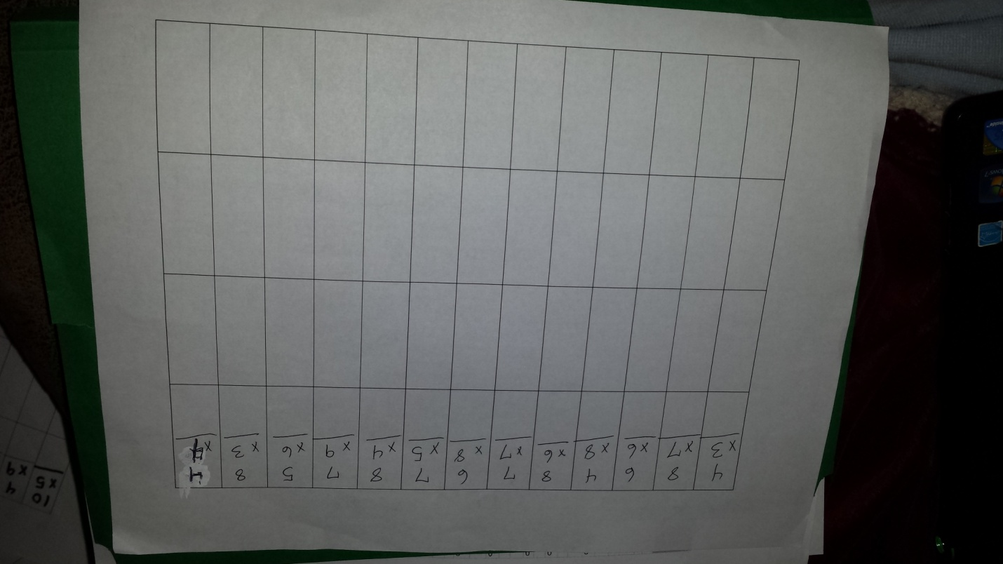
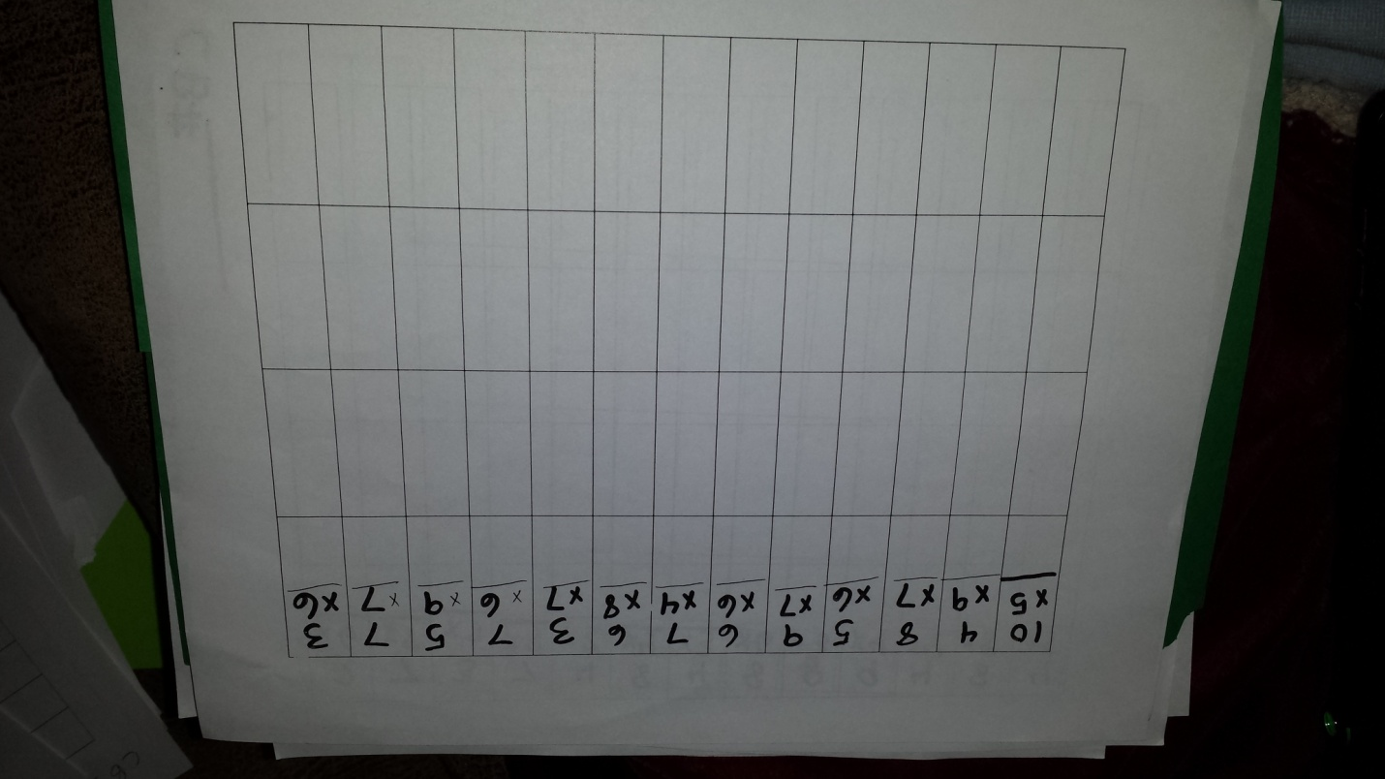
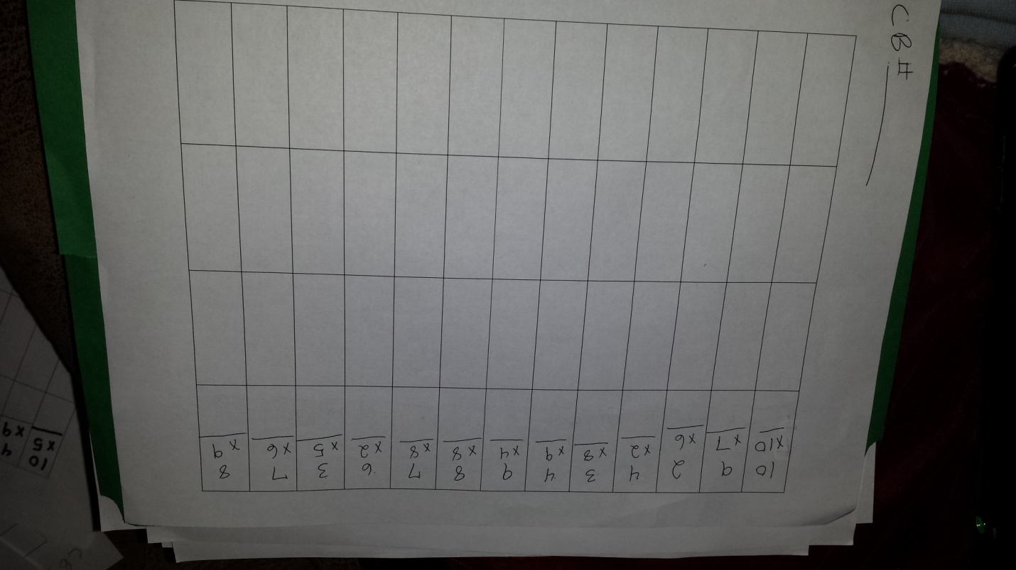
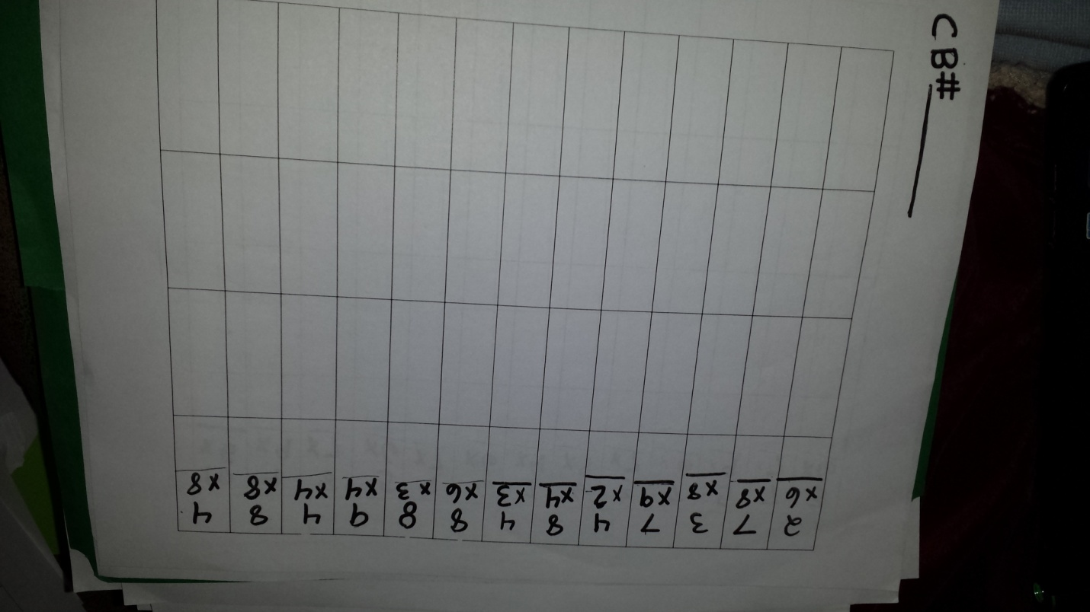
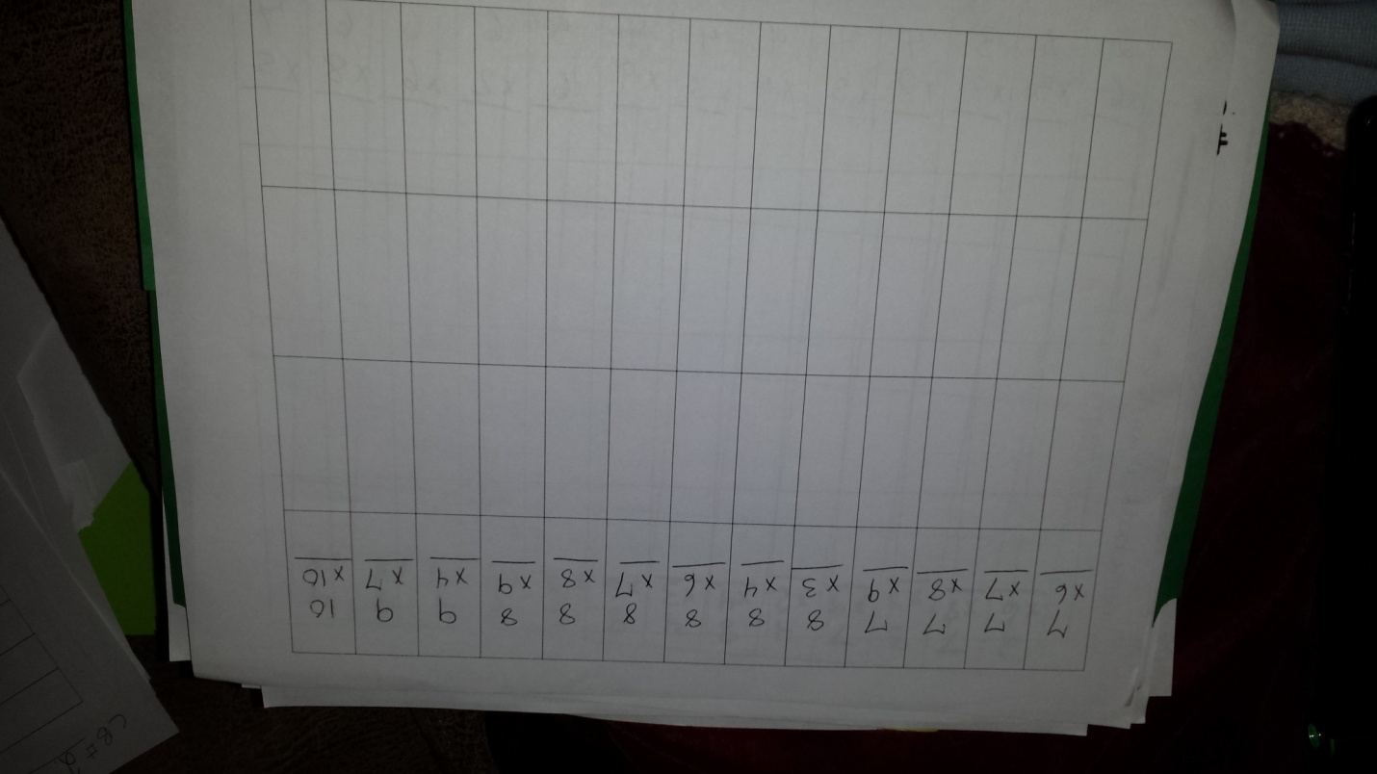
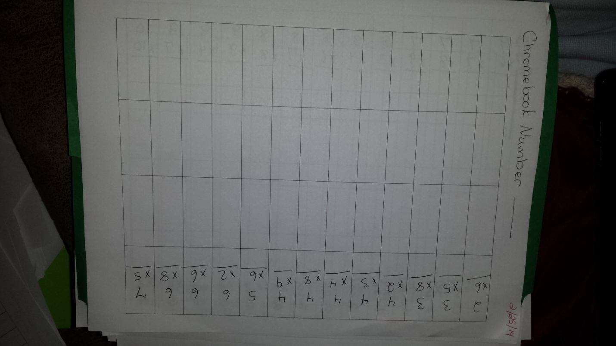

Appendix B
Pretest and Posttest page 1
Pretest and Posttest Page 2
Likert ScaleInterview Protocol
Background Information
Date:
Name:
Position:
Years Teaching:
Questions Related to Daily Reviews
- Is there a relationship between students’ fluency and automaticity with basic facts and their achievement levels in the current curriculum?
- Do students that demonstrate fact fluency and automaticity have an easier time completing required coursework?
- Does automaticity increase students’ access to the prescribed curriculum?
- Do you think brief daily reviews can be an effective strategy to increase automaticity?
- How can this strategy be improved?
- Is a daily review to increase automaticity a strategy you would implement in your classroom? Why or why not?

Appendix C

INFORMED CONSENT FORM
Western Governors University

Master of Arts in Mathematics Education (K-6)

Capstone Written Project

Lindsay N. Boylan
Introduction
You are invited to participate in a research project being conducted by researchers from Western Governors University. Dr. Robert W. Murray and Lindsay N. Boylan are conducting research to determine the most effective ways to teach automaticity of basic multiplication facts to sixth grade students.
Description of the project: The purpose of this research is to determine if brief daily reviews of multiplication facts have a positive impact on students’ fluency and automaticity.
- This research will run concurrently with the prescribed Common Core State Standards for Mathematics course of study as set forth by the North Carolina Department of Public Instruction, Pitt County Schools, the Farmville Middle School Mathematics Department, and the regular classroom teacher.
- The research will be conducted in the regular classroom for 12-15 consecutive days for five minutes before the initiation of regularly scheduled daily mathematics instruction.
- All students are expected to participate fully in all routine classroom activities as directed by the regular classroom teacher.
- What the participant will be required to do: complete timed 66-question multiplication fact fluency pretest and posttest, participate in daily reviews (ten days), and complete a Likert scale (questionnaire) in addition to regular participation in the curricular activities.
Benefits and Risks of this study: The benefits of participation in this study include increasing fluency and automaticity for the individual student and perhaps increasing students’ ability to readily access the prescribed mathematics curriculum. Benefits to general educational settings include developing a strategy to remediate necessary component skills while concurrently teaching composite skills. No risks are expected.
Confidentiality: Participant confidentiality will be maintained at all times. Records will only be seen by the researchers. All data that is reported will be aggregated. No participant names or identifying information will be used at any time during the research.
Voluntary participation and withdrawal: Participants are expected to participate in any regular classroom instruction but may choose to voluntarily participate or withdraw from video or audio taping and interviews. Generally, since surveys and questionnaires are used to inform instruction or measure pre-post gains, these are considered part of regular classroom instruction.
Participants may withdraw at any time from non-regular classroom instruction and will not be penalized for non-participation.

Participants may request that their individual results be excluded from the final report.
Questions, Rights and Complaints: If participants or legal guardians have any questions, concerns, or complaints about the research study, they may contact Mrs. Lindsay Boylan at the following:
Phone: (304) 685 – 7274
Email: lnboylan@wgu.edu
Participants and legal guardians have a right to the results of the study.

Consent statement: By signing this informed consent, participants and legal guardians agree to participate in the research.

________________________ _______________________
Signature of Participant Signature of Legal Guardian
_________________________ _______________________
Typed/printed Name Typed/printed Name
__________________________ ________________________
Date Date

Appendix D
Pre-coding Activity

